Laboratory Report Book

|  |  |  |
| --- | --- | --- |
| **Laboratory** | **Date** | **Page** |
| Lab 1 | 9/1/16 | 2 |
| Lab 2 | 9/716 | 5 |
| Lab 3 | 9/14/16 | 7 |
| Lab 4 | 9/21/16 | 8 |
| Lab 5 | 10/13/16 | 10 |
| Lab 6 | 10/19/16 | 13 |
| Lab 7 | 11/10/16 | 19 |
| Lab 8 | 10/17/16 | 23 |
| Lab 9 | 11/1/16 |  |

**ECE- 1270- Fall 2016 Laboratory 1**

**River Schenck 09/01/2016** Lab 1: Computer Circuit Simulation

**Objective:** To learn how to use Multisim and to make and analyze a circuit.

**Preliminary:** Looked at Multisim and read about it. Learned how Multisim works and what its for.

**Procedure:**

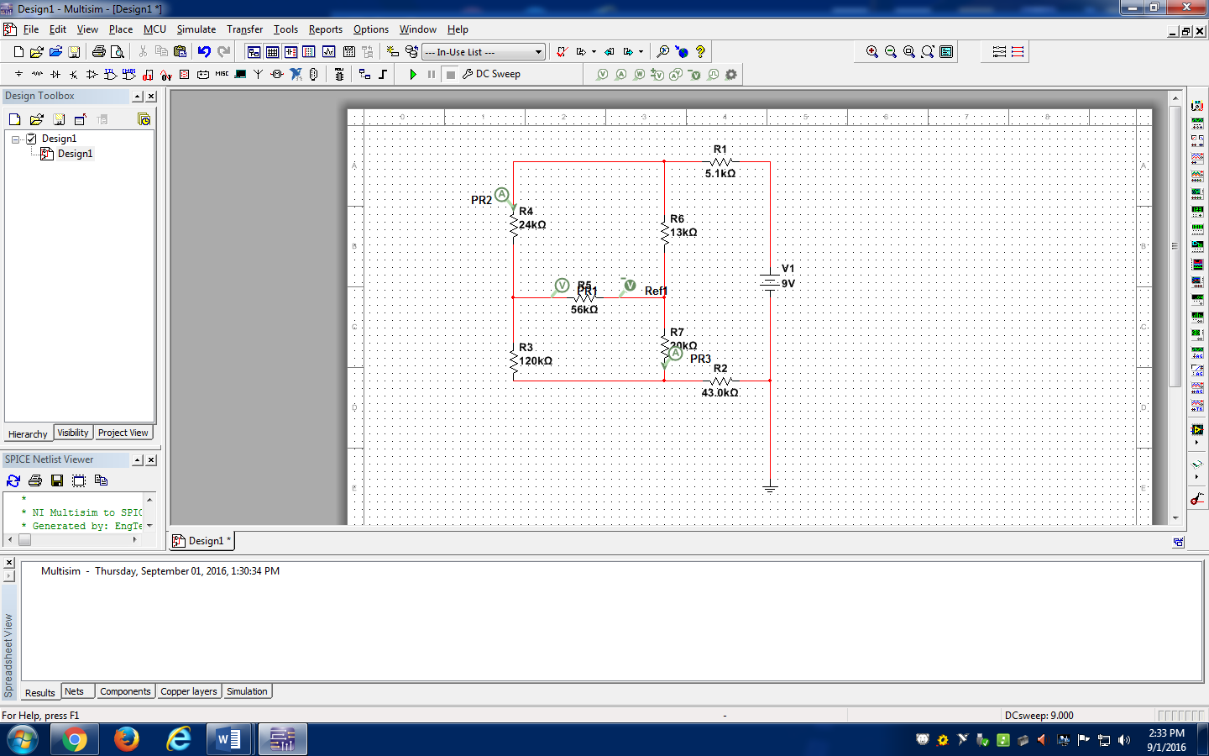

The above image is the circuit I created using Multisim.

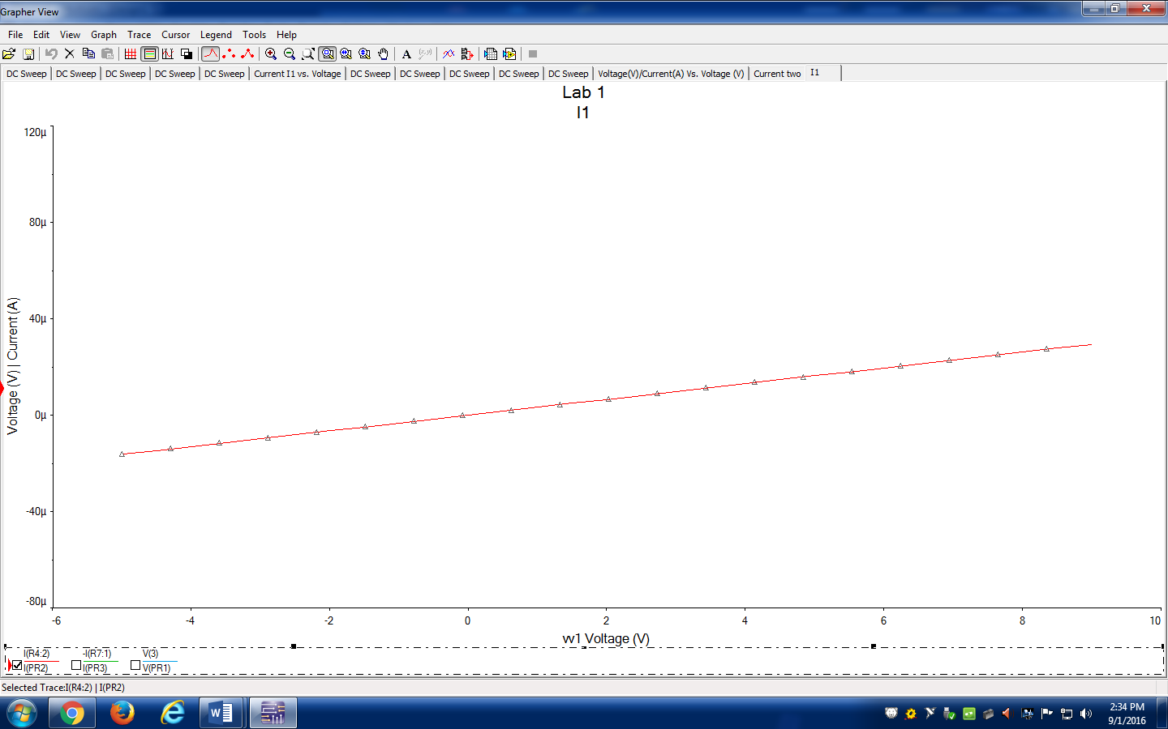

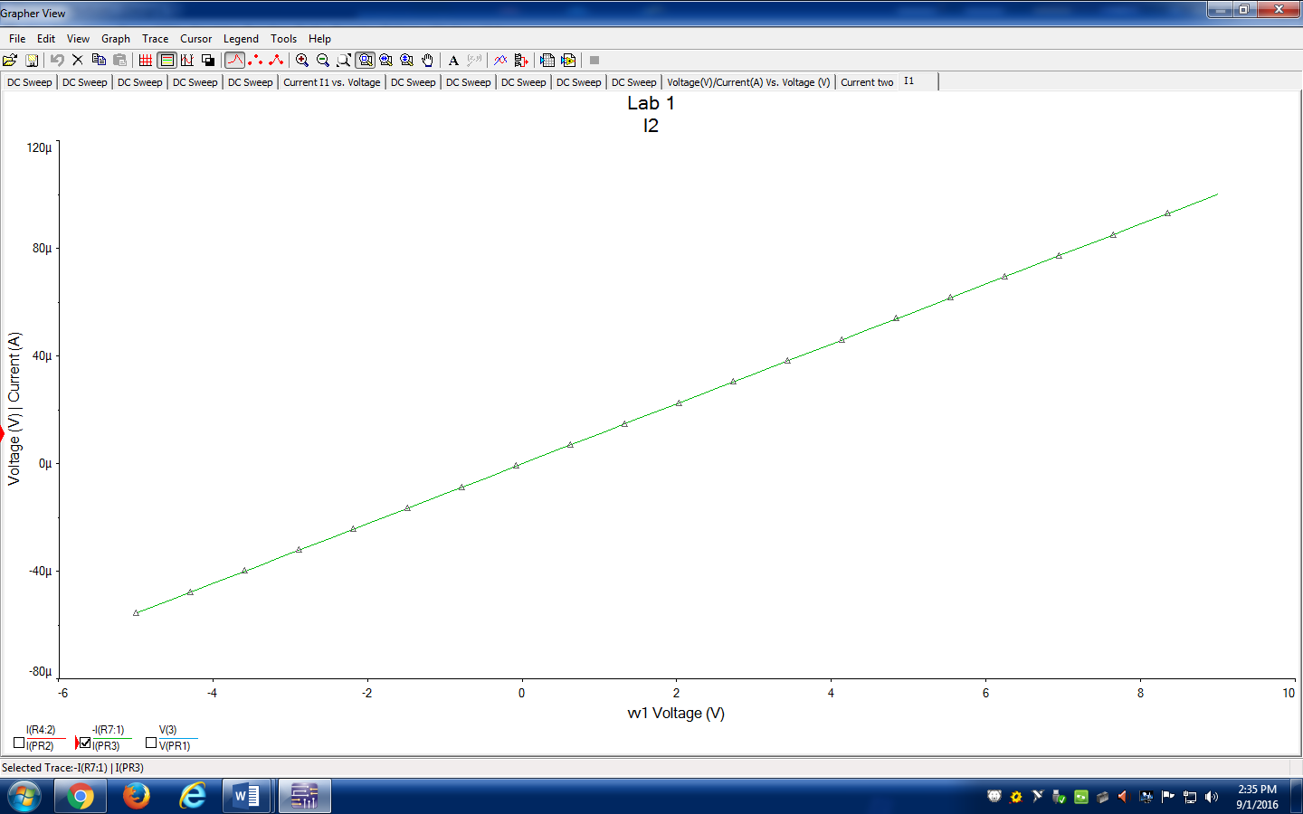

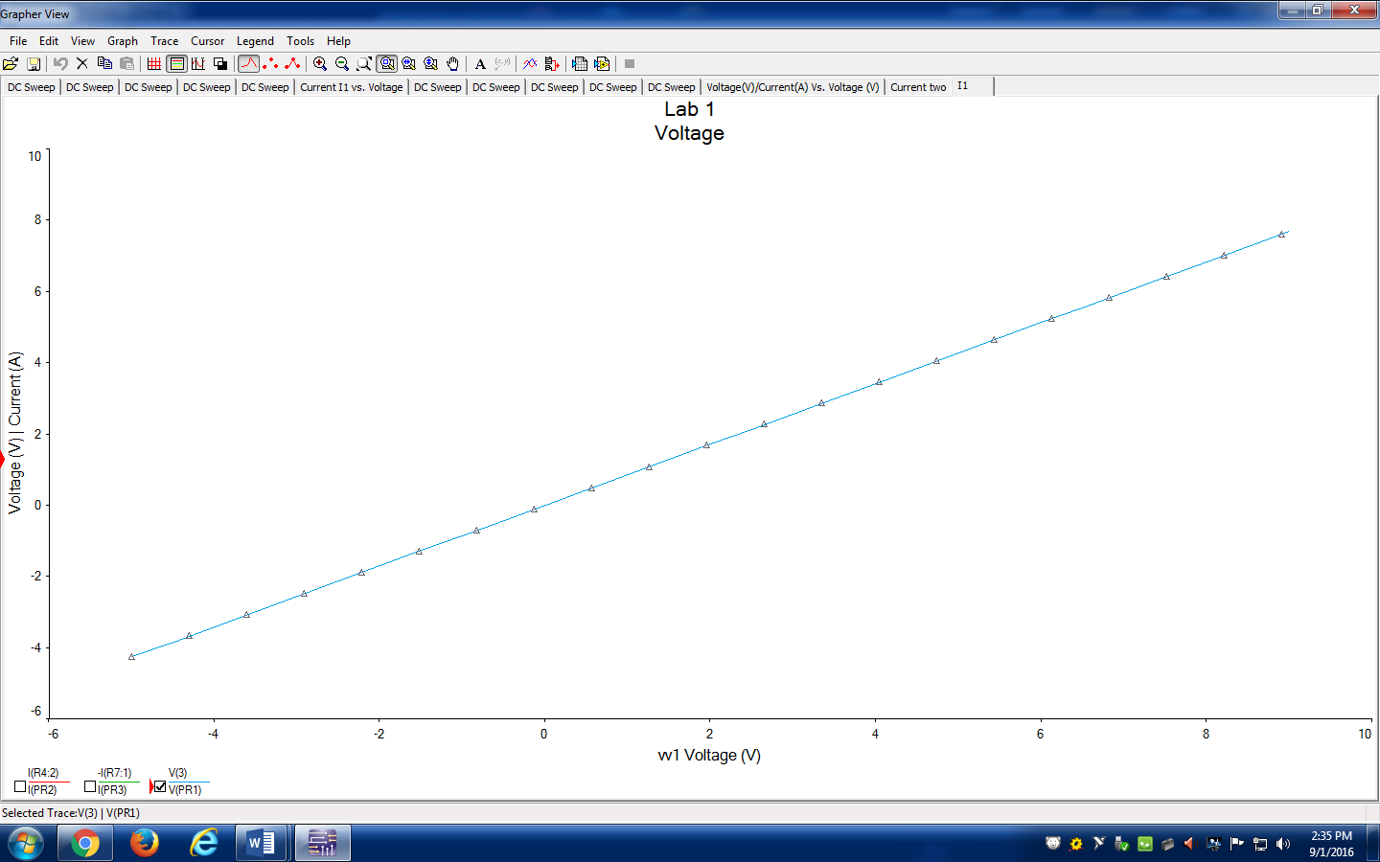

These are the graphs that I created using the DC sweep tool.

**Conclusion:** A key point I learned from this lab is to make sure you type in the values correctly because in the long run they could throw you off. I also learned that sometimes you have to look in smaller increments or you will not be seeing what you are supposed to.

**ECE- 1270- Fall 2016 Laboratory 2**

**River Schenck 09/08/2016** Lab 2: DC Test Equipment

**Objective:** To learn about the Dc test equipment and become familiar with the equipment so we know how to use it.

**Preliminary:**

**1-**

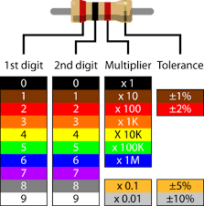

**B**lack **B**eatles **R**unning **O**ver **Y**our **G**arden **B**ring **V**ery **G**rey **W**eather

2-

10±5%

47000±10%

65000±5%

1000000±10%

8200±10%

3- Series 14.7kΩ. Parallel 3.19kΩ

4-

|  |  |  |
| --- | --- | --- |
| R1 | 2.88V | 6.12mA |
| R2 | 6.12V | 6.12mA |

5-

|  |  |  |
| --- | --- | --- |
| R1 | .639mA | 3V |
| R2 | 1.361mA | 13.6V |

6- The multi meters have certain plugs for the wires to go into. You can’t just plug them in or else it will break the multi meter. I wish I would have remembered this during the lab because it took me a while to get it.

**Procedure:**

1. Holding with fingers 9.6kΩ. On the breadboard 9.8kΩ.
2. The more accurate value was on the breadboard; your body has some electrical resistance which will effect the flow of electricity.
3. Series 14.4kΩ. Parallel 3.15kΩ.

The values were close to as expected. There is resistance in the board and there is small error allowed in resistors.

1. The Power supply was set to 9.0V and the voltmeter measured 8.95V. The error was .05V or .5% error.
2. a.)4.7kΩ- 2.87V drop. 10MΩ- 6.08V drop. The actual values are very close to my calculated values.

c.) 6.20mA

1. 9.5V both the resistors. Current of 10kΩ is 1.38mA and 4.7kΩ is .65mA.

**Conclusion**

1. In procedure 1 and 2 we measured the resistance on the breadboard and in our hands. Our body has a little bit of resistance which will make it lower.

2-

|  |  |  |
| --- | --- | --- |
|  | Voltage drop | Current |
| Procedure/Preliminary 4 | .003%,.007% | .013% |
| Procedure/Preliminary 5 | 68%, 43% | .014%, .017% |

1. To make sure you are working with the same units. So don’t be intertwining mA with A.
2. 200Ω resistance in human body. 2V would put current through your body.
3. It is when you can ground from either positive or negative. It would be nice because you can use either to ground.

**ECE- 1270- Fall 2016 Laboratory 3**

**River Schenck 09/14/2016** Lab 3: Equivalent Resistance

**Objective:** To understand equivalent resistances for series, parallel, T, and π resistive networks.

**Preliminary: 1-**

3.1-25.1 Ω Vdrop-3.3kΩ-1.30V 6.8kΩ-2.68V 15kΩ-5.91V Current-.394 A

3.2- 1.9 Ω Vdrop-10V Current-3.3k Ω-3.03mA 6.8k Ω-1.47mA 15k Ω-.66mA

2- 3.3k Ω-4.13V drop, Current 3.03mA, 6.8k Ω- 9.99V drop, Current 1.47mA 15k Ω- 9.99V Current .67mA

3- Rab-10.1k Ω Rac- 18.3k Ω Rbc-21.8k Ω

4- Rab- 4.96k Ω Rac-2.8k Ω Rbc-1.9k Ω

**Procedure-**

1. 3.3k Ω- 1.27V drop, .35A 6.8k Ω-2.66V drop, .44A 15k Ω-5.92V drop, .89A
2. 3.3k Ω- 9.92V drop, .309mA 6.8k Ω-9.92V drop, 1.5mA 15k Ω-9.92V drop, .68mA
3. 3.3k Ω- 4.1V drop, 2.17mA 6.8k Ω-5.86V drop, .91mA 15k Ω-5.86V drop, .43mA
4. Rab-9.94k Ω Rac- 18.06k Ω Rbc- 21.12k Ω
5. Rab-4.88k Ω Rac- 2.81k Ω Rbc- 5.95k Ω

Conclusion:

**ECE- 1270- Fall 2016 Laboratory 4**

**River Schenck 09/21/2016** Lab 4: Kirchhoff’s Laws and DC Analysis

**Objective:**

To apply Kirchoff’s Laws to the analysis of a simple resistive circuit and experimentally verify the laws.

**Preliminary:**

1. Req- 73.2k Ω Current-279mA Power- 2.51w

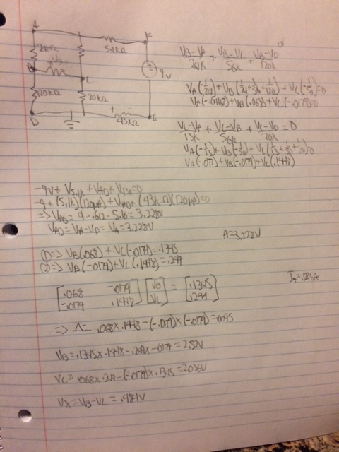

**Procedure:**

1-73.4 Ω The difference is that there is a little bit of error in the experiment from the machine and such.

2-Ohm meters don’t work with power

3.

a .03mV

b 5.1 Ω ,.6V 24 Ω, .7V 13 Ω, 1.2V 56 Ω, .5V 120 Ω, 2.4V 20 Ω, 1.5V 43 Ω- 5V

c. -.7V+.5V+.2V=0V

4.

a.I1=.045mA I2=.14mA

b. .122mA+ .093mA-.128mA=.-.0mA

c. .101mA-.122mA+.21mA=-.0mA

|  |  |  |  |  |  |  |  |  |
| --- | --- | --- | --- | --- | --- | --- | --- | --- |
|  | **5.1** | **24** | **13** | **56** | **120** | **20** | **43** | **Total P dissapated** |
| **Calculated** | **.124mA** | **.0295mA** | **.092mA** | **.009mA** | **.021mA** | **.1018mA** | **.12mA** |  |
| **V** | **.63V** | **.708V** | **1.192V** | **.484V** | **2.52V** | **2.036V** | **5.16V** |  |
| **P-dissipate** | **.078W** | **.021W** | **.11W** | **.0045W** | **.053W** | **.207W** | **.62W** | **1.09W** |
| **Measured** | .122mA | **.03mA** | **.092mA** | **.009mA** | **.021mA** | **.101mA** | **.12mA** |  |
| **V** | .61V | **.70V** | **1.18V** | **.48V** | **2.2V** | **1.9V** | **5.1V** |  |
|  |  |  |  |  |  |  |  |  |

Conclusion-

The values are very very close. This lab made me finally break through and know what is going on. I built a circuit exactly like the one we were given. I was very confused at first but this lab helped me break through and understand what I am doing. Nodal analysis finally makes sense and so does solving a circuit. I know know how to find power dissipated, where as before this lab I had no idea how to do that. I understand how to find current and voltage now. It used to be unclear but it makes a lot of sense now. I learned how to correctly measure the current going through a circuit while in parallel. This lab helped me understand this class a lot better.

**ECE- 1270- Fall 2016 Laboratory 5**

**River Schenck 10/13/2016** Lab 5: Thevenin – Norton Equivalent

**Objective:** To demonstrate equivalent circuits using computer simulations and actual circuits. Students should gain additional experience using computer simulations tools.

**Preliminary:**

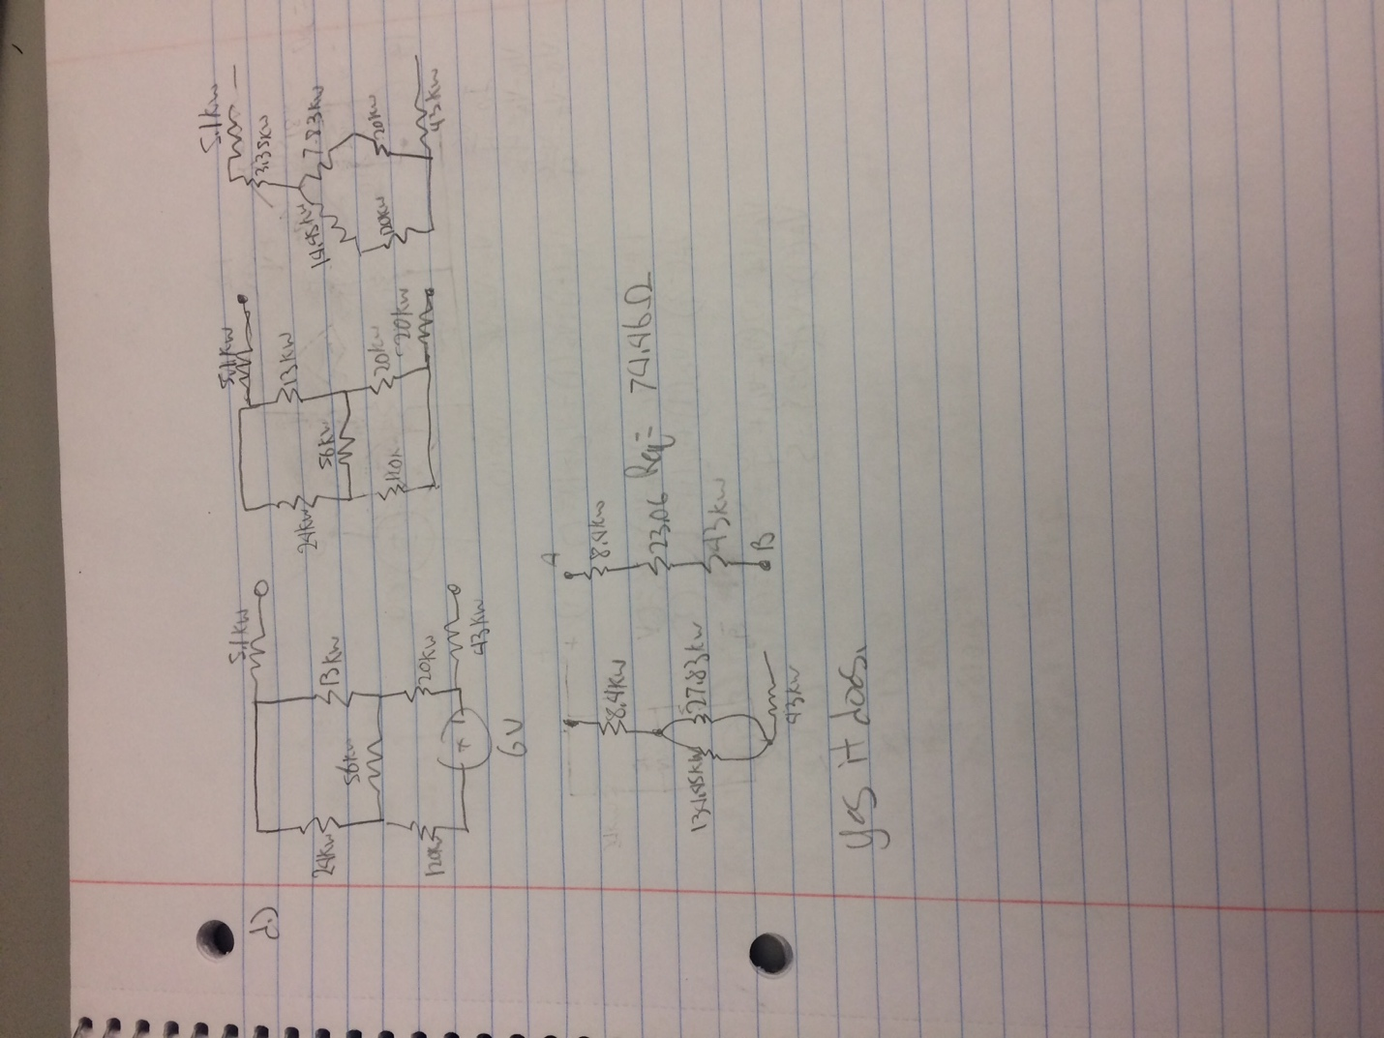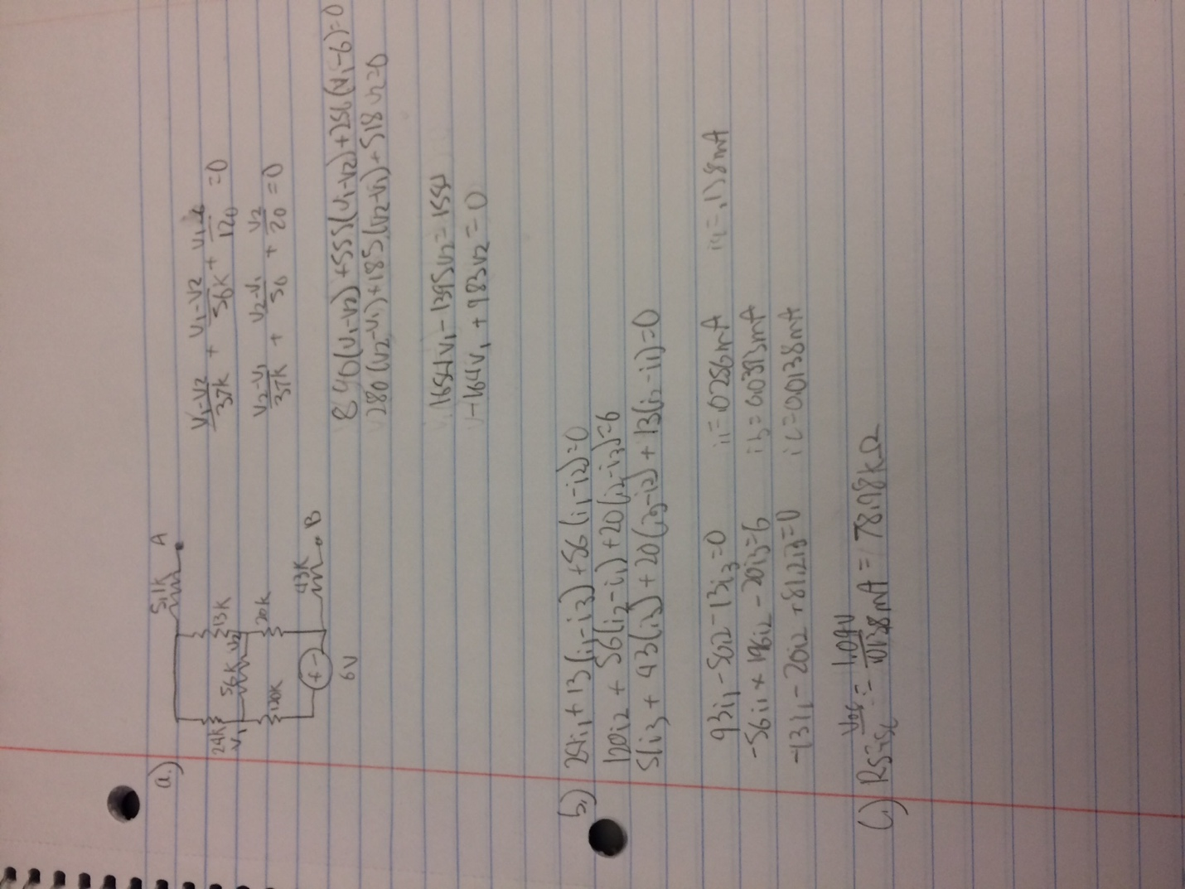

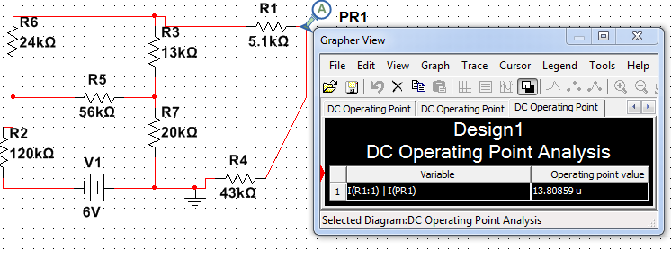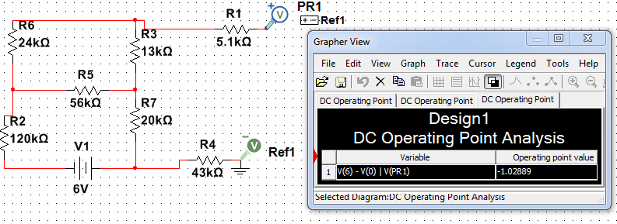

Req=Voc/Isc=1.03/.0000138=74.64k Ω

**Procedure:**

1. 1.03V (see calculated in photos)
2. 73k Ω
3. 71.9 Ω

4.)

|  |  |  |
| --- | --- | --- |
| Voltage Drop (V) | Current (A) | Power Dissipated (w) |
| .52 | .0000067 | .0000035 |
| .34 | .0000091 | .00000316 |
| .68 | .0000000044 | .000000003 |

5.)

|  |  |  |  |
| --- | --- | --- | --- |
| R | Voltage | Current( micro) | Power (micro) |
| 75k Ω | .498 V | .007 A | .0035 W |
| 37k Ω | .35 V | .009 A | .0032 W |
| 148k Ω | .663 V | .0048 A | .0032 W |

1. Neither of them were super simple to me. If I had to pick one, I think the first one was a little bit more simple.
2. They were very close. They were barely off at the micro scale. In a real life scenario this would be almost negligible.

**ECE- 1270- Fall 2016 Laboratory 6**

**River Schenck 10/19/2016** Lab 6: Operational Amplifiers

**Objective:** Introduce students to the design of and use of common operational amplifier (Op Amp) circuits.

**Preliminary:**

1. 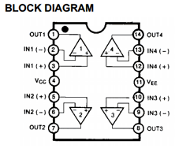

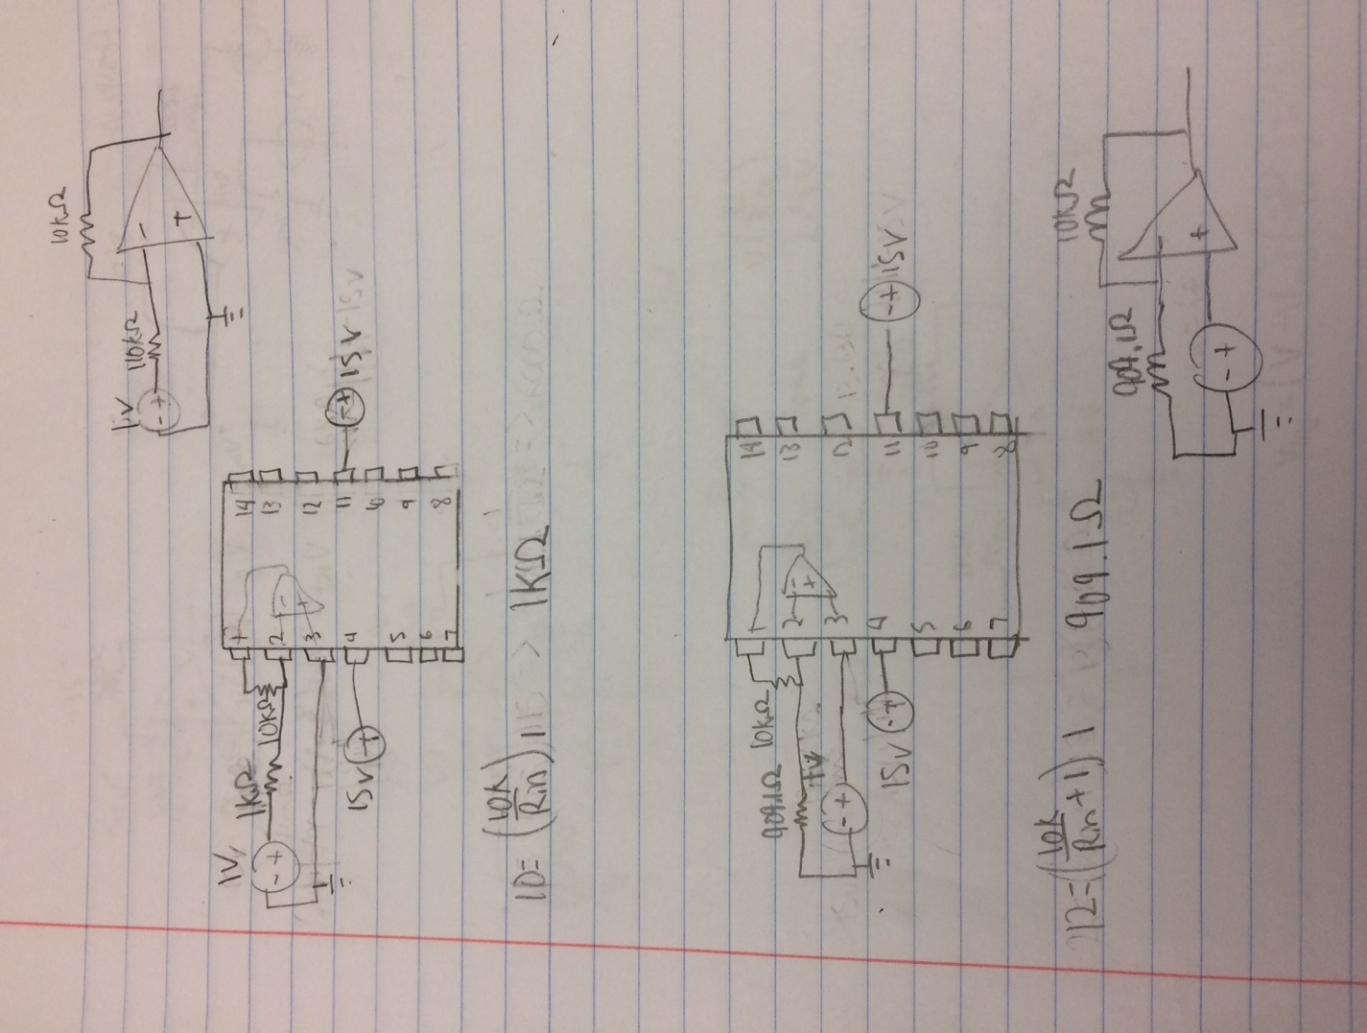

1. non Inverting 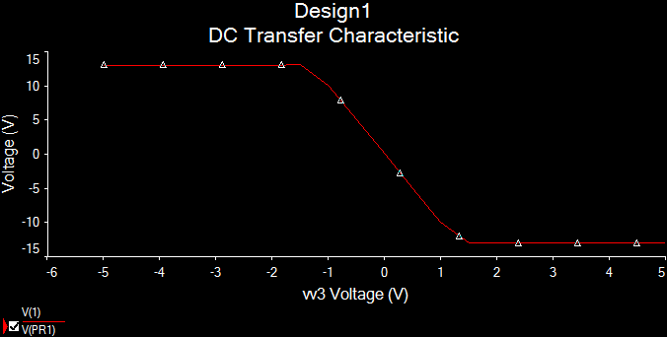

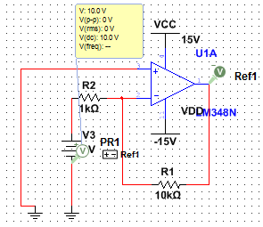

Inverting

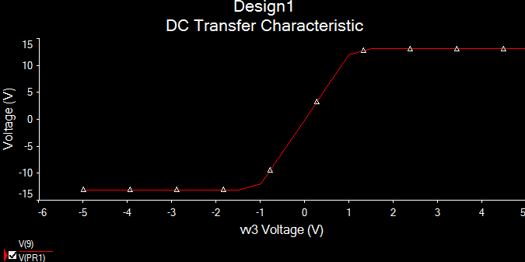

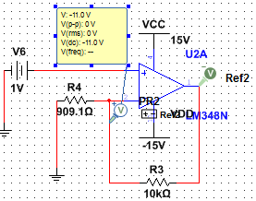

transient

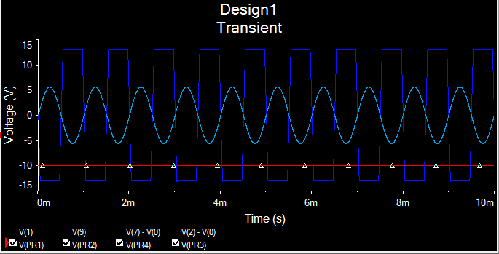

**Procedure-**

1. Inverting

B) Voltage Gain- Output V/ Input V= 10V

C) .002V Virtual short.

D.) .945 mA 985 Ω

E) at about 3Vpp

F) .447 V Not a virtual short.

2- Non inverting

B) 10.94

C) 0.005 V Yes virtual short.

D) .003mA 1.7k Ω

E) 1.3 V

F) .6312 Not a virtual short.

**3-**

|  |  |  |
| --- | --- | --- |
| Measured | Op Amp | % Error |
| 9.9k Ω | 10.18k Ω | 2.8% |
| 510 Ω | 477 Ω | 6.5% |
| 5.01k Ω | 5.1k Ω | 1.8% |
| 1.5k Ω | 1.52k Ω | 1.3% |

Conclusion-

I learned a lot about op amps in this lab. I did not understand op amps before hand but now they made sense to me. At first I burned up an op amp because I was not paying attention to where I was putting my voltage. My calculated and simulated values came out to look similar. My ohmmeter was a lot more accurate than I thought it was going to be. The most percent error that I got was 2.8% which is not very much at all. That error is within the percent error on the resistor its self. My ohm meter turned out very good.

**ECE- 1270- Fall 2016 Laboratory 7**

**River Schenck 10/19/2016**

**Objective:**

Introduce students to the fundamentals of test equipment commonly used to test and analyze AC circuits.

**Preliminary**: Knowledge of equipment

**Procedure: Procedure:**

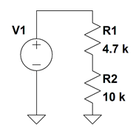

1. **Measure and record the voltage drop across the 4.7 kΩ and 10 kΩ resistor with the multimeter. Use both the DC and AC voltage settings. Display these values in a table and verify that KVL (Kirchhoff’s Voltage Law) is still valid.**

|  |  |  |  |
| --- | --- | --- | --- |
|  | **AC** | **DC** | **Oscilloscope** |
| **4.7kΩ** | .455V | .0010V | .46V |
| **10kΩ** | .97V | .0019V | .96V |

1. **Now use the oscilloscope and measure the voltage drop across the 4.7 kΩ and 10 kΩ. Sketch the resulting waveforms. Do the waveforms agree with KVL?**

Yes they agree with KVL.

1. 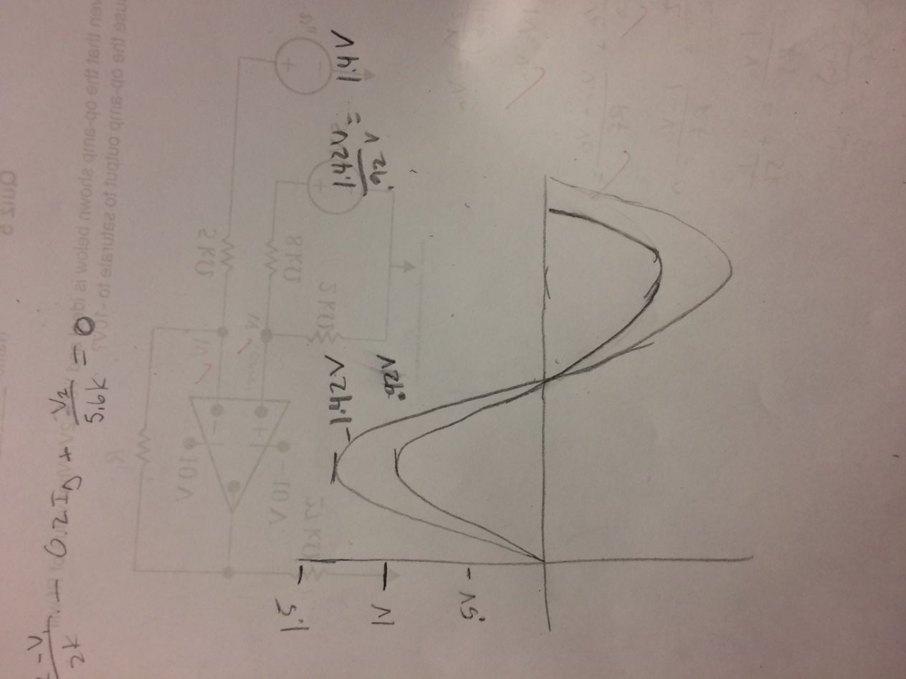
2. **Calculate the ratio between the Peak voltages measured**

|  |  |
| --- | --- |
| 4.7kΩ | 10kΩ |
| 1.47 | 1.44 |

1. **Using the oscilloscope, measure the period and the frequency (1/T) of the voltage waveform dropping across the 4.7 kΩ and 10 kΩ resistor (the frequency should be 1 kHz).**

|  |  |  |
| --- | --- | --- |
|  | **Period** | **Frequency** |
| **4.7kΩ** | 1ms | 1kHz |
| **10kΩ** | **1ms** | 1kHz |

1. **Apply a 1 V, 1 kHz sinusoidal signal. Using Channel 1 of the oscilloscope to monitor the input voltage and Channel 2 to monitor the output, sketch the resulting display.**
2. 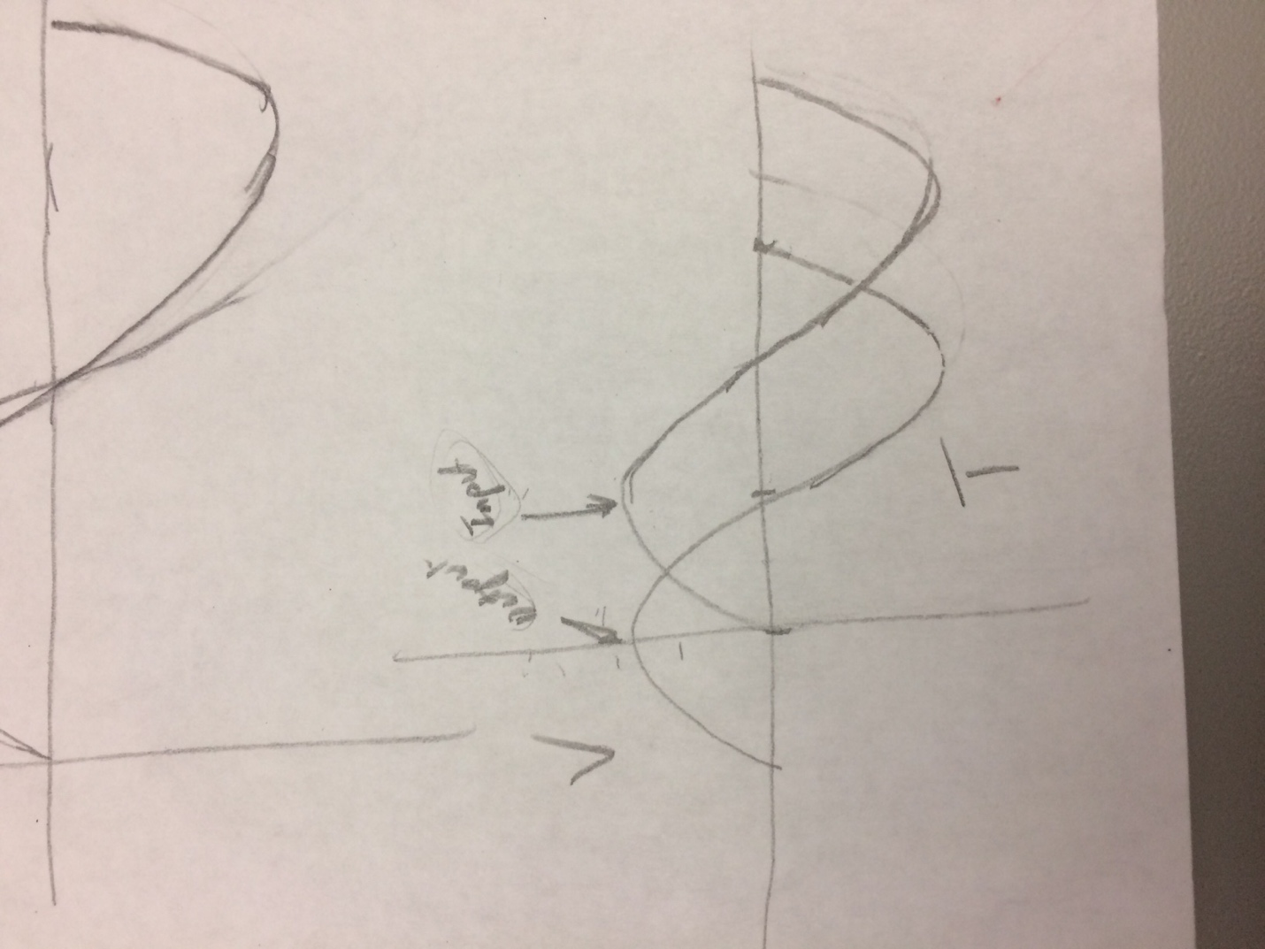
3. **Identify what mathematical expression the circuit implements. *Hint: Pay close attention to the phase variation between the input and output signals. Also take a note of the output amplitude level.***

The input is lagging the output by 90 degrees. The output is the integral of the input.

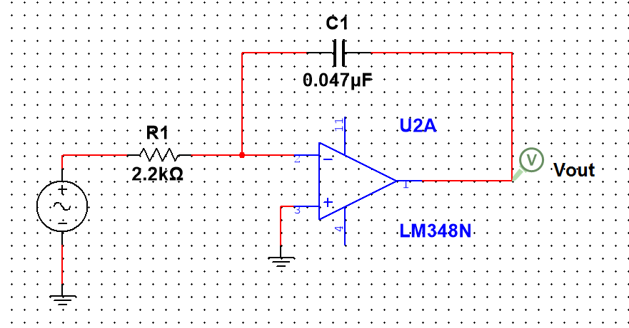

**Conclusion:**

We found that the multi meter and oscilloscope are both accurate measuring devices. The multi meter is easier to use and is more intuitive than the oscilloscope for DC circuits. When measuring AC circuits, it is easier to use an oscilloscope, to see all values( cosine/sine waves). When using a multi meter, only one digital reading come be measured.

**ECE- 1270- Fall 2016 Laboratory 8**

**River Schenck 10/19/2016** Lab 8: Phasor Circuit Analysis

**Objective:**

Introduce sinusoidal steady state analysis and show that Kirchhoff’s laws apply to phasors in the frequency domain.

**Prerequisite:**

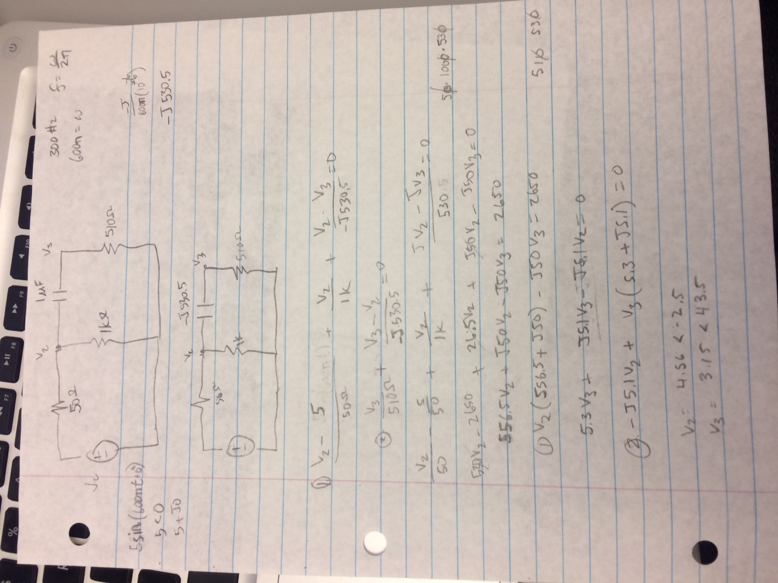

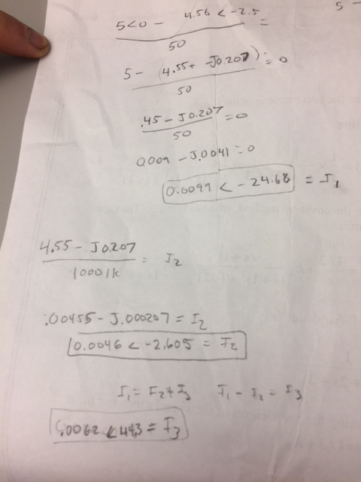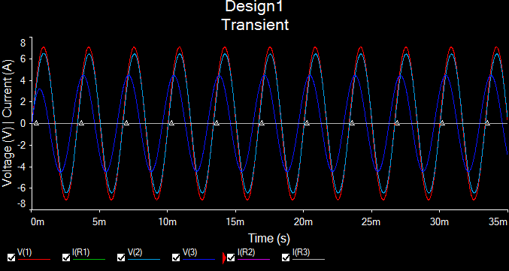

**Procedure:**

1. V3 Phase= 27 Degrees

Magnitude V2= 4.52 V

Magnitude V3= 3.92 V

1. I2= .0045 A

I3= .0076 <26.43

1. I1= .0121

VR1=.6V

1. Vac= 5.105V

Conclusion-

*Note* Our Preliminary Calculations are different from our measurements because we followed the labs instructions and used 5V as V2 but it really should have been 4.55V because the 50 Ohm resistor. So in my table I will display our measurements and calculations but I am not going to do % error because they are not going to be even close.

|  |  |  |  |  |  |  |
| --- | --- | --- | --- | --- | --- | --- |
|  | V1 | V2 | V3 | I1 | I2 | I3 |
| Calculated | 5V | 4.56V | 3.15V | .0099A | .0046A | .0062A |
| Measured | 5.105V | 4.52V | 3.92V | .0121A | .0045A | .0076A |

**ECE- 1270- Fall 2016 Laboratory 8**

**River Schenck 10/19/2016** Lab 9: AC Power

**Objective:**

Introduce Thevenin and Norton Equivalent circuits for sinusoidal steady state. Develop skills in using PSPICE for sinusoidal steady state analysis and as a design tool.

**Equipment and Components:**

1. Breadboard, Multimeter, Power supply, Function Generator, Oscilloscope.
2. Resistors (3): 1 kΩ.
3. Capacitors (1): 1 μF.
4. Inductor: 1 mH and others as necessary.

**Preliminary:**

1. Thevinin .5<-0.09degree V Impedance 1500-j318.68 Ω Norton .326<11.96 A
2. Power 21uw
3. 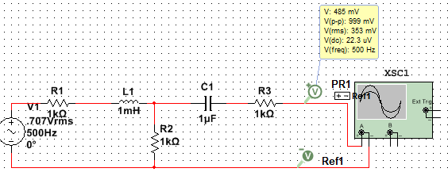

5-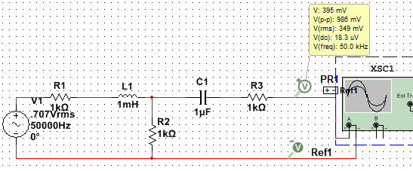

**Procedure:**

1. Vth= .5V In= .325 A

4: Irms^2*Zr= Powermax .325^2mA*1500Ω= .00002 w

5: The impedance would change to 1842 Ω roughly and therefor we would to change the load impedance to 1842 Ω at the frequency of 50kHz. That is because when frequency is increased impedance is changed depending on the capacitors and inductors in the circuit. The way to improve the power transfer at this frequency is to match the impedance in the load.

**Conclusion:**

|  |  |  |  |
| --- | --- | --- | --- |
|  |  |  | **Percent Error** |
| **Voltage** | .5V | .5V | 0% |
| **Current** | 326mA | 325mA | .4% |
| **Power** | .000021w | .00002w | 5% |

Possible reasons for discrepancies may be rounding differently. Our power that we calculated in the prerequisite was rounded just little bit differently than how we rounded in the procedure. This gave us a 5% error but we really had the same values but rounded at different points. The difference in current could be due to the resistors have a little bit error. We did not have any error with our voltage. We found that it is better to use 500Hz than to use 50kHz.